Lesson 3: Move a Car Using the Keyboard.

1. Complete playable code
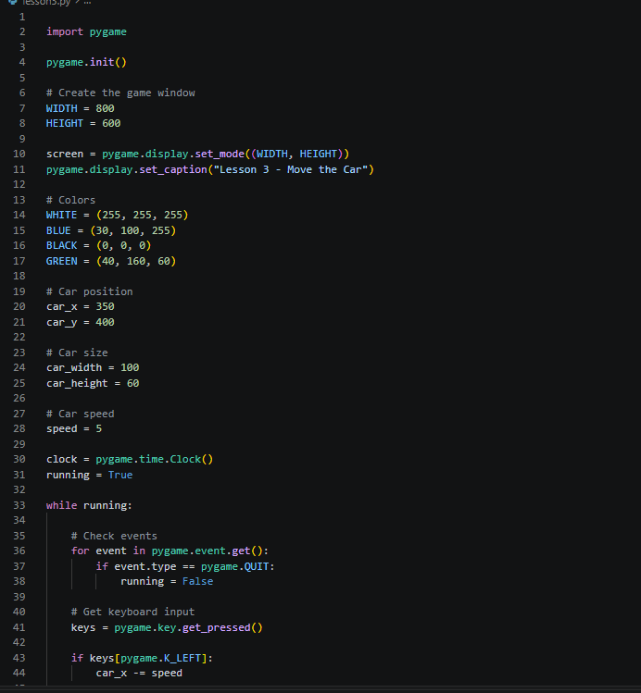
Create a file named lesson3.py and copy this code.
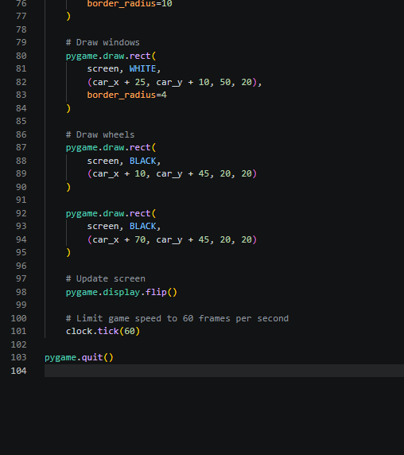
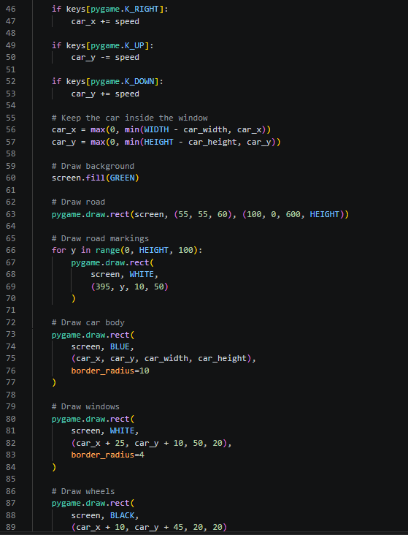
Run it:
python lesson3.py

2. How does keyboard movement work?
Let's understand the most important part.
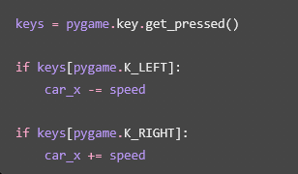
• pygame.key.get_pressed() checks which keys are being held down.
• pygame.K_LEFT checks the left arrow key.
• pygame.K_RIGHT checks the right arrow key.
• car_x -= speed moves the car to the left.
• car_x += speed moves the car to the right.
Key | Code | Movement
⬅️ Left | pygame.K_LEFT | Move left
➡️ Right | pygame.K_RIGHT | Move right
⬆️ Up | pygame.K_UP | Move up
⬇️ Down | pygame.K_DOWN | Move down
The same rule applies vertically:
Remember: the x-coordinate increases toward the right, while the y-coordinate increases toward the bottom.
3. What is game speed?
Look at this line:
speed = 5
Try changing it to:
speed = 10
The car will move faster because its position changes by 10 pixels instead of 5 each frame.
This line is also important: clock.tick(60)
It limits the game to approximately 60 frames per second, helping the movement run at a consistent speed on different computers.

